**EXERCISE**

***Question # 01:***

Complete the following:

a) Create a base class named **Rectangle** that includes data members for the length and width of a Rectangle, as well as functions to assign and display those values. Derive a class named **Block** that contains an additional data member to store height, and contains functions to assign and display the height. Write a **main**() function that demonstrates the classes by instantiating and displaying the values for both a Rectangle and a Block.

b) Add a member function to the **Rectangle** class that computes the area of a Rectangle (length multiplied by width). Add a member function to Block that has the same name, but overrides the computation with a volume calculation (length by width by height). Write a main() function that demonstrates the classes.

***Question # 02:***

Create a base class named **Book**. Data fields include title and author; functions include those that can set and display the fields. Derive two classes from the **Book** class: **Fiction**, which also contains a numeric grade reading level, and **NonFiction**, which contains a variable to hold the number of pages. The functions that set and display data field values for the subclasses should call the appropriate parent class functions to set and display the common fields, and include specific code pertaining to the new subclass fields. Write a main() function that demonstrates the use of the classes and their functions.

***Question # 03:***

Create a class named **MusicalComposition** that contains fields for title, composer, and year written. Include a constructor that requires all three values and an appropriate display function. The child class **NationalAnthem** contains an additional field that holds the name of the anthem’s nation. The child class constructor requires a value for this additional field. The child class also contains a display function. Write a main() function that instantiates objects of each class and demonstrates that the functions work correctly.

***Question # 04:***

A CollegeCourse class includes fields representing department, course number, credit hours, and tuition. Its child, LabCourse, includes one more field that holds a lab fee charged in addition to the tuition. Create appropriate functions for these classes, and write a main()function that instantiates and uses objects of each class.

***Question # 05:***

Create a **RestaurantMeal** class that holds the name and price of a food item served by a restaurant. Its constructor requires arguments for each field. Create a **HotelService** class that holds the name of the service, the service fee, and the room number to which the service was supplied. Its constructor also requires arguments for each field. Create a **RoomServiceMeal** class that inherits from both RestaurantMeal and HotelService. Whenever you create a RoomServiceMeal object, the constructor assigns the string “room service” to the name of the service field, and Rs. 40.00 is assigned to the service fee inherited from HotelService. Include a RoomServiceMeal function that displays all of the fields in a RoomServiceMeal by calling display functions from the two parent classes. Additionally, the display function should display the total of the meals plus the room service fee. In a main()function, instantiate a RoomServiceMeal object that inherits from both classes. For example, a “steak dinner” costing Rs. 1999.00 is a “room service” provided to room 1202 for a Rs. 40.00 fee.

***Question # 06:***

Create a **Painting** class that holds the painting title, artist name, and value. All Paintings are valued at $400 unless they are **FamousPaintings**. Include a display function that displays all fields. The **FamousPainting** subclass overrides the Painting value and sets each Painting’s value to $25,000. Write a main() function that declares an array of 10 Painting objects. Prompt the user to enter the title and artist for each of the 10 Paintings. Consider the Painting to be a **FamousPainting** if the artist is one of the following: Degas, Monet, Picasso, or Rembrandt. Display the 10 Paintings.

***Question # 07:***

Implement the following scenario in C++:

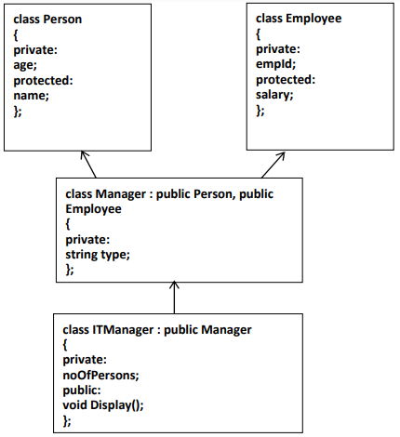

1. The Display() function in “**ITManager**” should be capable of displaying the values of all the data members declared in the scenario (age,name,empId,salary,type,noOfPersons) without being able to alter the values.
2. The “int main()” function should contain only three program statements which are as follows:
3. In the first statement, create object of “**ITManager**” and pass the values for all the data members: ITManager **obj(age,name,empId,salary,type,noOfPersons);**
4. In the second statement, call the Display() function.
5. In the third statement, return 0.